Notice

Screenshot installation for XAMPP:

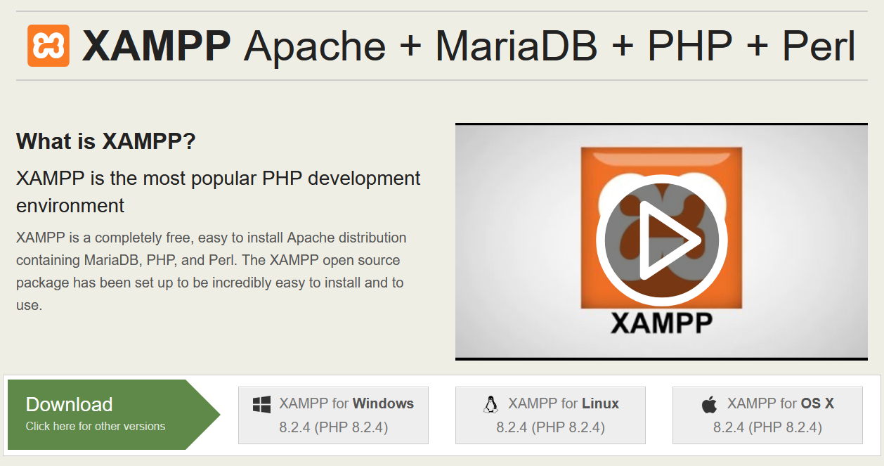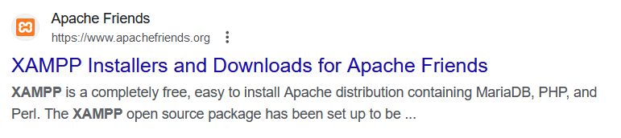where to download

Screenshot installation for Visual Studio Code:

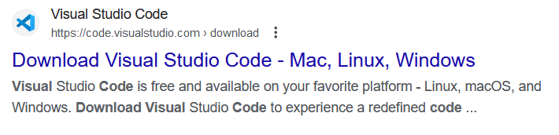Where to download

